Project Planning Phase
Project Planning Template (Product Backlog, Sprint Planning, Stories, Story points)

Date | 26 June 2026
Team ID
Project Name | Automated Network Request Management System
Maximum Marks | 5 Marks

Product Backlog, Sprint Schedule, and Estimation (4 Marks)
Sprint | Functional Requirement (Epic) | User Story Number | User Story / Task | Story Points | Priority | Team Members
Sprint-1 | Project Setup | USN-1 | Create the scoped application, configure user roles, create custom tables (u_network_database and u_network_task), design Service Catalog item, and configure the Service Portal. | 8 | High
Sprint-2 | Request Management & Approval Workflow | USN-2 | Develop the network request form, implement Business Rules, configure Manager approval workflow, validate request details, and update request status. | 9 | High
Sprint-3 | Workflow Automation & Task Management | USN-3 | Configure Flow Designer, automatically create implementation tasks, assign Network Engineers, configure email notifications, and implement status tracking. | 8 | Medium
Sprint-4 | Testing & Deployment | USN-4 | Perform system testing, resolve defects, generate reports and dashboards, prepare project documentation, and deploy the solution. | 5 | High

Project Tracker, Velocity & Burndown Chart (4 Marks)
Sprint | Total Story Points | Duration | Sprint Start Date | Sprint End Date (Planned) | Story Points Completed (as on Planned End Date) | Sprint Release Date (Actual)
Sprint-1 | 8 | 2 Days | 22 June 2026 | 23 June 2026 | 8 | 23 June 2026
Sprint-2 | 9 | 2 Days | 24 June 2026 | 25 June 2026 | 9 | 25 June 2026
Sprint-3 | 8 | 2 Days | 26 June 2026 | 27 June 2026 | 8 | 27 June 2026
Sprint-4 | 5 | 1 Day | 28 June 2026 | 28 June 2026 | 5 | 28 June 2026

Velocity
- Total Story Points: 30
- Total Duration: 7 Days
Average Velocity = 30 ÷ 7 ≈ 4.3 Story Points/Day

Burndown Chart:
A burn down chart is a graphical representation of work left to do versus time. It is often used in agile software development methodologies such as Scrum. However, burn down charts can be applied to any project containing measurable progress over time
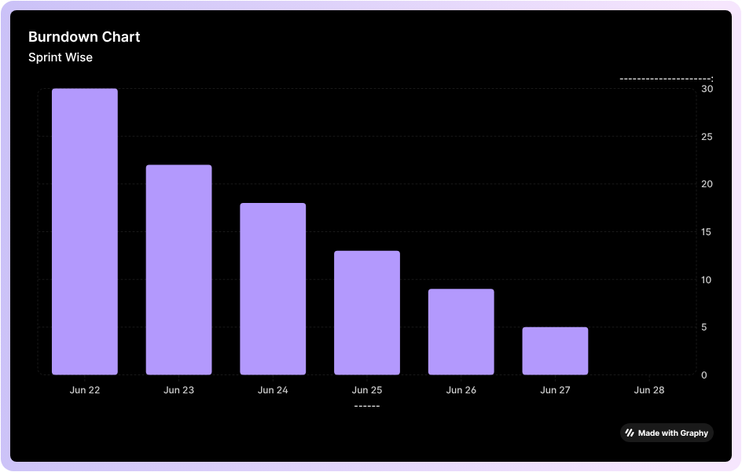

https://www.visual-paradigm.com/scrum/scrum-burndown-chart/
https://www.atlassian.com/agile/tutorials/burndown-charts

Reference:
https://www.atlassian.com/agile/project-management
https://www.atlassian.com/agile/tutorials/how-to-do-scrum-with-jira-software
https://www.atlassian.com/agile/tutorials/epics
https://www.atlassian.com/agile/tutorials/sprints
https://www.atlassian.com/agile/project-management/estimation
https://www.atlassian.com/agile/tutorials/burndown-charts

